[**VISUAL PHYSICS ONLINE**](http://www.physics.usyd.edu.au/teach_res/hsp/sp/spHome.htm)

**THERMODYNAMICS**

**THERMODYNAMICS SYSTEMS**

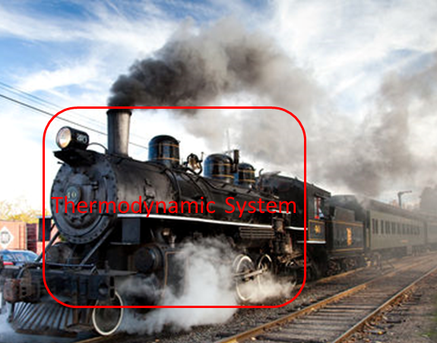

The topic **thermodynamics** is very **complicated** but a topic of extreme importance.

“Thermodynamics is a funny subject. The first time you go through it, you don’t understand it at all. The second time you go through it, you think you understand it, except for one or two points. The third time you go through it, you know you don’t understand it, but by this time you are so used to the subject, it doesn’t bother you any more.” Arnold Sommerfeld (1868 – 1951 famous German physicist)

Ludwig Boltzmann (1844 – 1906) who spend much of his life studying thermodynamics (statistical mechanics), died in 1906 by his own hand. Paul Ehrenfest (1880 – 1933) carrying on the work, died similarly. So did another disciple, Percy Bridgman (1882 – 1961). “Perhaps it will be wise to approach the subject with caution”. David Goodstein

The industrial revolution in the 18th and 19th Century only occurred because of the efforts of made by scientists and engineers in their work on thermodynamics.

**James Watt** (1736 – 1819) was a Scottish inventor, mechanical engineer, and chemist who constructed a steam engine in 1781, which was fundamental to the changes brought by the Industrial Revolution in Great Britain and the rest of the world.

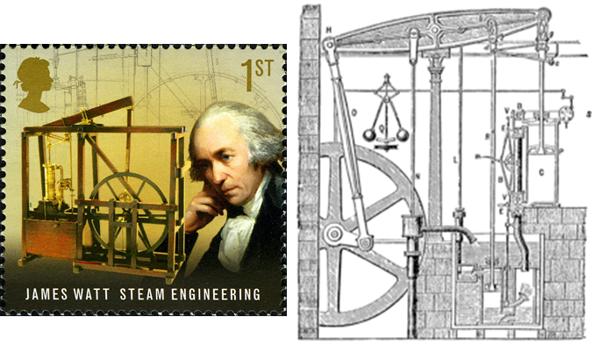

**Count Rumford** (**Sir Benjamin Thompson** 1753 –1814) was an American-born British physicist and inventor whose challenges to established physical theory were part of the 19th century revolution in thermodynamics. He served as lieutenant-colonel of the King's American Dragoons, part of the British Loyalist forces, during the American Revolutionary War. After the end of the war he moved to London, where his administrative talents were recognized when he was appointed a full colonel and in 1784 he received a knighthood from King George III. He was a prolific designer and drew designs for warships. He later moved to Bavaria and entered government service there, being appointed Bavarian Army Minister and re-organizing the army, and, in 1791, was made a Count of the Holy Roman Empire.

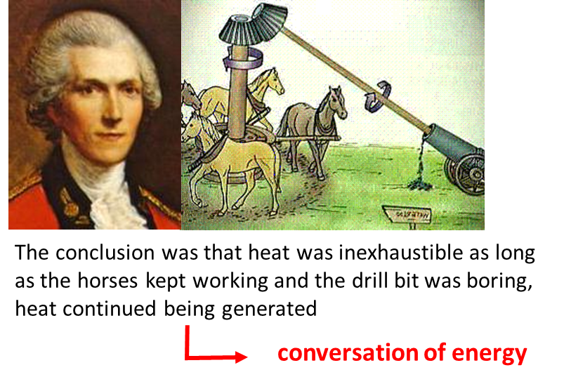

**George Stephenson** (1781 – 1848) renowned as the "Father of Railway” was an English engineer who built the first public inter-city railway line in the world to use **steam locomotives** (The Liverpool to Manchester Railway open in 1830). The Victorians considered him a great example of diligent application and thirst for improvement. His rail gauge of 1435 mm sometimes called "Stephenson gauge" is the standard gauge by name and by convention for most of the world's railways.

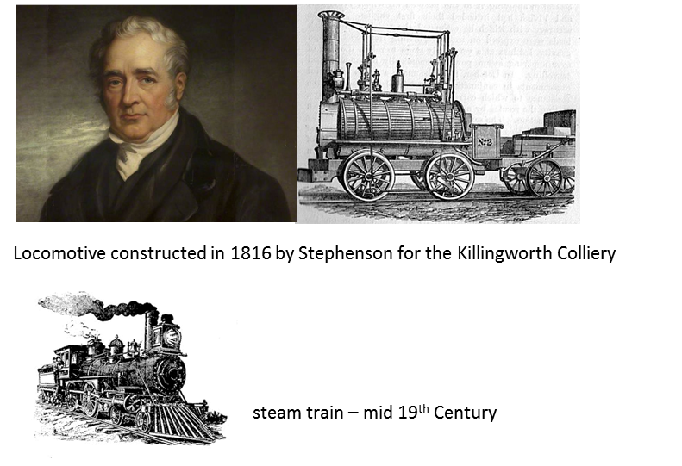

**Nicolas Léonard Sadi Carnot** (1796 – 1832) was a French military engineer and physicist, often described as the "father of thermodynamics". In his only publication, the 1824 monograph Reflections on the Motive Power of Fire, Carnot gave the first successful theory of the maximum efficiency of heat engines.

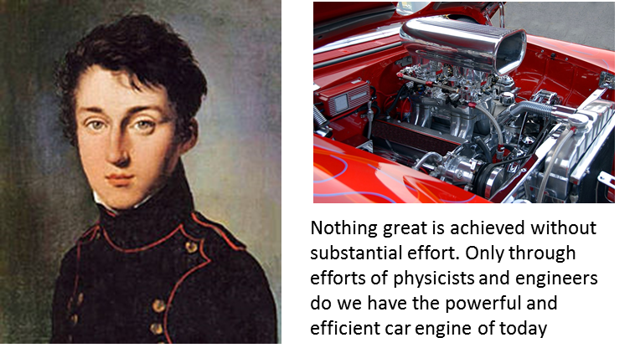

**What do we mean by hot?**

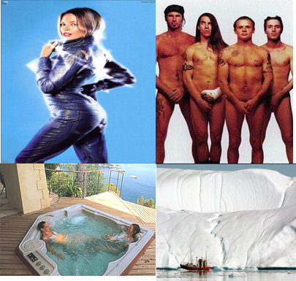

**Why is thermodynamics a complex subject?**

There are many reasons why thermodynamics is complicated. The real-world is complex and every event within the entire Universe and even our thoughts are associated with thermodynamics processes. To model thermal processes, we need to consider both the macroscopic view and the microscopic view (molecular view). Because of the complexity of this topic, the material presented in this Module on Thermodynamics is at a greater depth than that prescribed in the Syllabus.

The Syllabus content statement on Thermodynamics is poorly done and if you covered the material as given in the Syllabus you would have an imprecise and very incomplete knowledge of the workings of the Universe. Without knowing about the concept of **entropy** and the **Second Law of Thermodynamics**, you are not in position to understand thermodynamic process. Just because entropy is a very abstract idea, it should have been mentioned in the Syllabus.

Why do some things happen, while others do not? The answer lies in the Law of Conservation of Energy and the Second Law of Thermodynamics – the total entropy change  of an isolated System is always greater than zero or equal to zero .

A good many times I have been present at gatherings of people who, by the standards of traditional culture, are thought highly educated and who have with considerable gusto been expressing their incredulity at the illiteracy of scientists. Once or twice I have been provoked and have asked the company how many of them could describe the Second Law of Thermodynamics. The response was cold: it was also negative. Yet I was asking something which is about the scientific equivalent of: Have you read a work of Shakespeare’s?

C. P. Snow (1905 – 1980: famous English physical chemist and novelist)

**Every student of physics should have some conceptual understanding of Entropy and the Second law of Thermodynamics.**

The other major reason why studying thermodynamics is complex, is the problem of ***language***. We commonly use the words such as energy, work, heat, heat energy, heat transfer, temperature, hot and cold. The use of these words clashes with their scientific use. Colloquially, the word **heat** is often confused with **temperature**. In Physics, these two words are not synonymous.

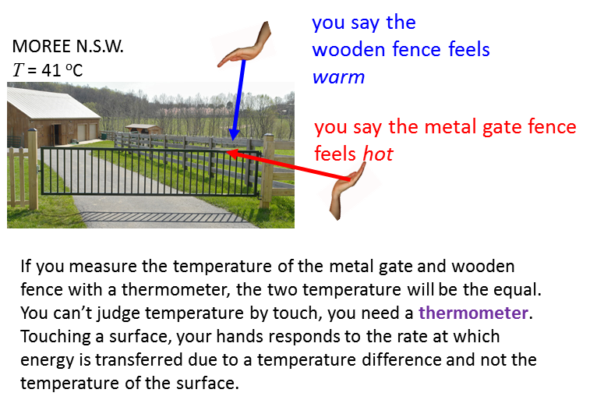

Also, in the development of thermodynamics in the 18th Century, heat was thought to be a fluid substance and could be contained in something. Even today, if you examine 10 books on heat and temperature they will have at least 6 different interpretation of the meaning of heat. Even today, physicists have difficulty with the scientific language when it comes to the terms heat and heat transfer.

Remember that Physics is not about the real-world. Many approximations and simplifications are necessary in constructing models to describe, explain and predict behaviour of real events. However, often the predictions give numerical results that are in excellent agreement with actual measurements.

Our starting point in the study of thermodynamics is identify the thermal System of interest. A **thermodynamics System** is defined as a collection of many particles such as atoms or molecules. A cup of coffee can be your thermal System or even yourself. In this Module, we will only consider simple thermodynamics Systems.

Thermodynamics in some sense is simple. You can measure a set of parameters of the System at any time and see how they change by the exchange of energy between the System and surrounding environment. We will consider the exchange of energy to and from the System in terms of work and heat .  and  are **not** functions of time. You can’t measure  or  at time t.  and  are simply the causes of the change in the System parameters which are referred to as **state variables**.

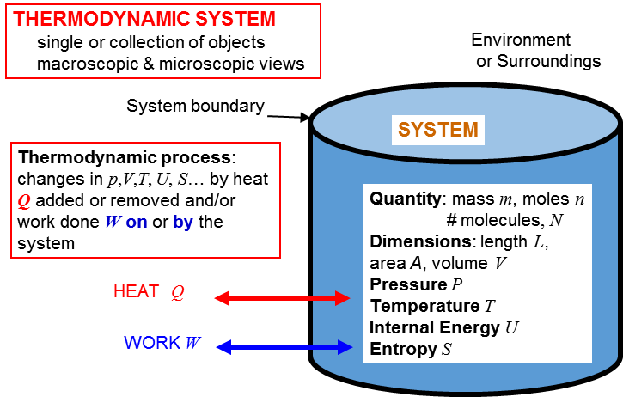

For example, we can take marathon man who melted as our System.

At the end of this Module you will have a good understanding of events leading to the tragedy. You, knowing a bit of Thermal Physics, could save a life. Thousands of people have died in heat wave conditions. People have died just sitting in a sauna. Knowing why, these events maybe be prevented in future. I always thought that the melting man incident was rare. You should do a web search on marathon man who melted and find that it not so rare an incident.

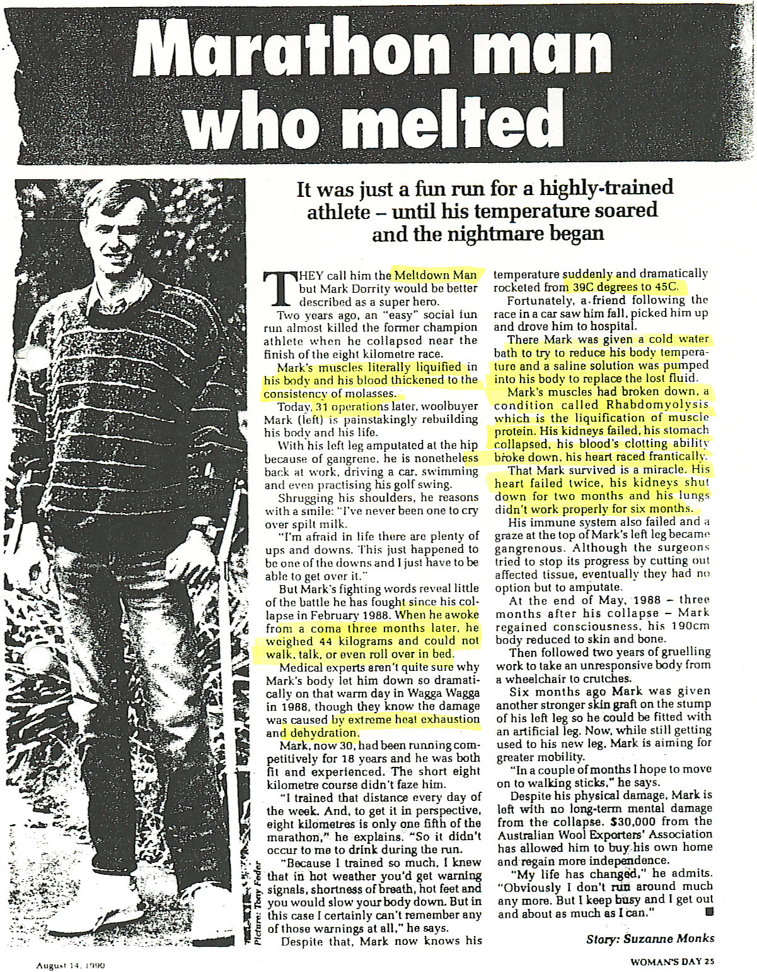

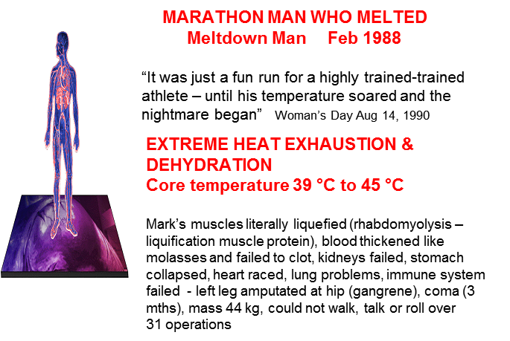

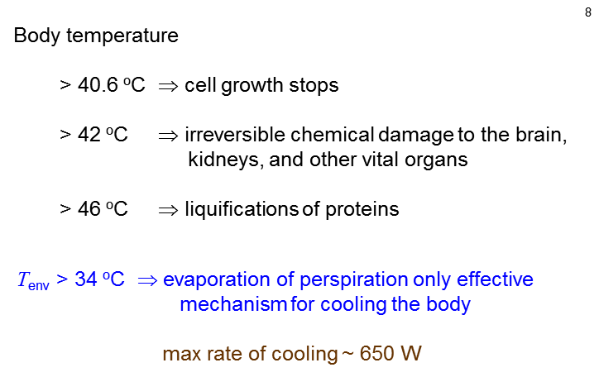

We will consider only Systems which contain solids, liquids and gases. Our System is always at rest, but not the constituents of the System which are always in continual, random (chaotic) motion.

Gravitational, electrical, magnetic, chemical, nuclear effects are all ignored.

A **solid** is a macroscopic System with a definite shape and volume. It consists of molecules connected by spring like molecular bonds. Each molecule is always jiggling about and vibrating around an equilibrium position.

A **liquid** in more complicated than a solid or gas. The molecules are close together as possible, but the molecules are free to move about and deform to fit the shape of the container. The molecules interact through each other by weak molecular bonds.

A **gas** is a System in which each molecule moves through space as a free noninteracting particle which often collides with other molecules and the walls of the container and in the process, there are exchangers of energy. The gas fills the container.

These three states of matter are referred to as **phases**. Phase changes occur for example, when a solid melts to form a liquid.

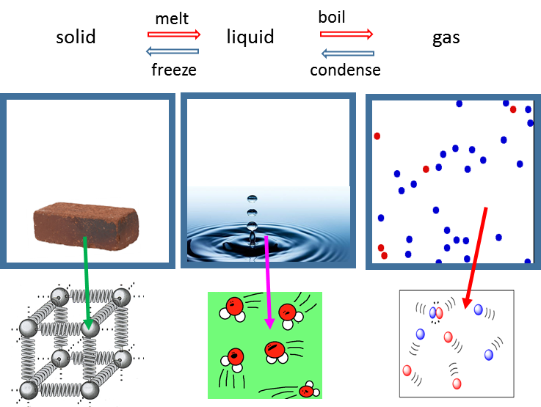

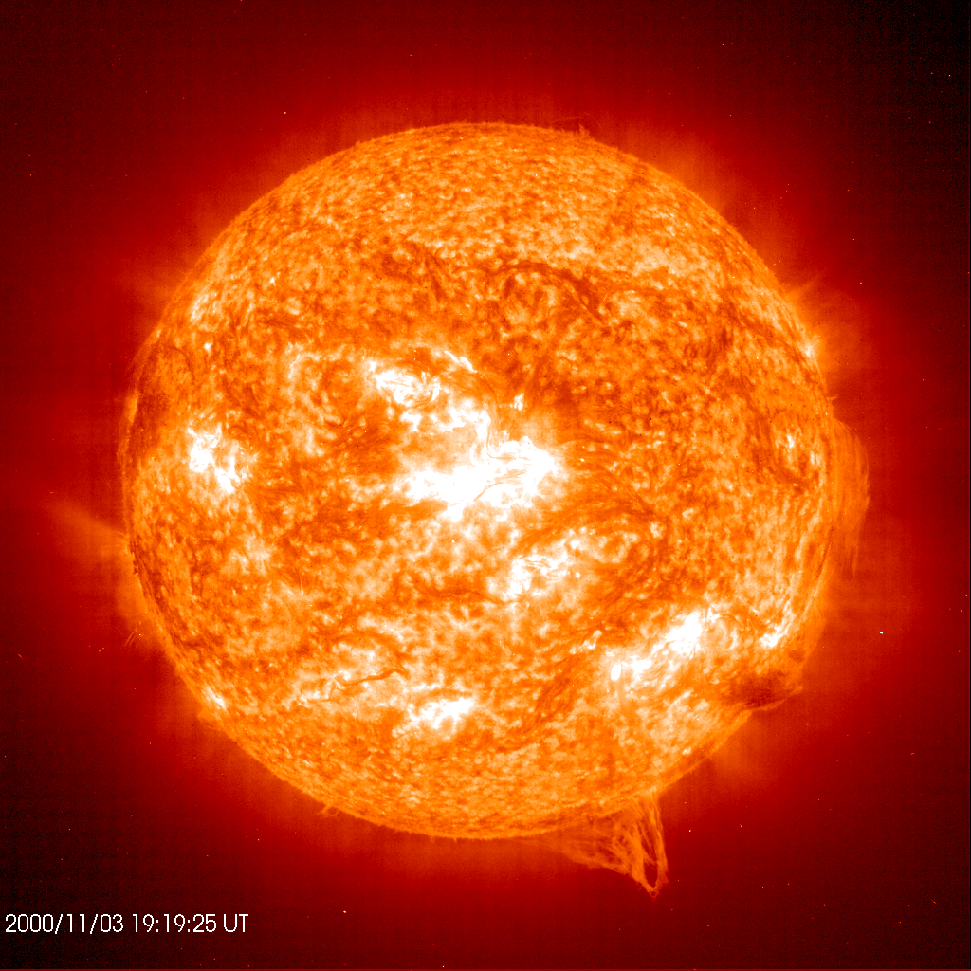The fourth state of matter is a plasma. It is the most prevalent phase of matter in the Universe as a whole. The Sun and other stars are mainly plasma. A plasma is a neutral gas comprising charged particles of positive ions and free electrons: the atoms are ionized by being stripped of their electrons.

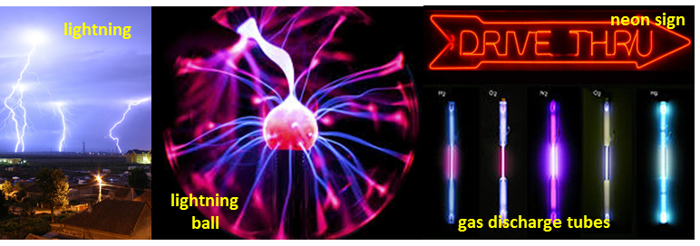

[VISUAL PHYSICS ONLINE](http://www.physics.usyd.edu.au/teach_res/hsp/sp/spHome.htm)

If you have any feedback, comments, suggestions or corrections please email:

Ian Cooper School of Physics University of Sydney

ian.cooper@sydney.edu.au